Section 5: Starting our Complex App 2

40. What’s next?

41. Let’s begin App 2

* Create a folder. This will be the main folder and the main file named app.js
* Use the express framework that will listen to incoming requests. Pick up express from npm. Create the json file that will serve as the ingredient list by npm init -y. json file will keep track of the packages needed.
* Install now the express, npm install express. We can now use the express framework in app.js file. const express = require(‘express’)
* Setup the express server, ‘node_modules’ is now available. Create a variable calling the express. let app = express()
* Tell the app what should it do when it receives a get request to the base url. .get consists of 2 arguments. 1st is the base url (‘/’). 2nd is a function that uses (req, res) parameters in the function. Express will pass the objects into the function when it’s called. res.send is the respond send when function is called. include the html template in res.send (home-guest.html).
* Create a new folder named views, it will contain html files. Create the home-guest.ejs, paste the raw html code.
* Connect the home-guest.ejs to app.js. Configure app.js, app.set(‘views’, ‘views’). 1st ‘views’ is fixed, 2nd ‘views’ is the folder created to contain the html templates. Express now knows where to find the ‘views’ or the templates. Tell express what templating engine to be use, app.set(‘view engine’, ‘ejs’). Ejs is one of the engines, others are pug, handlebar. Each template has its own syntax and features. Install ejs, npm install ejs. Instead of res.send, render the hopme-guest, res.render(‘home-guest’)
* Tell the app to begin listening for in-coming request at port 3000.
* Other features are unavailable because of the absence of the css. 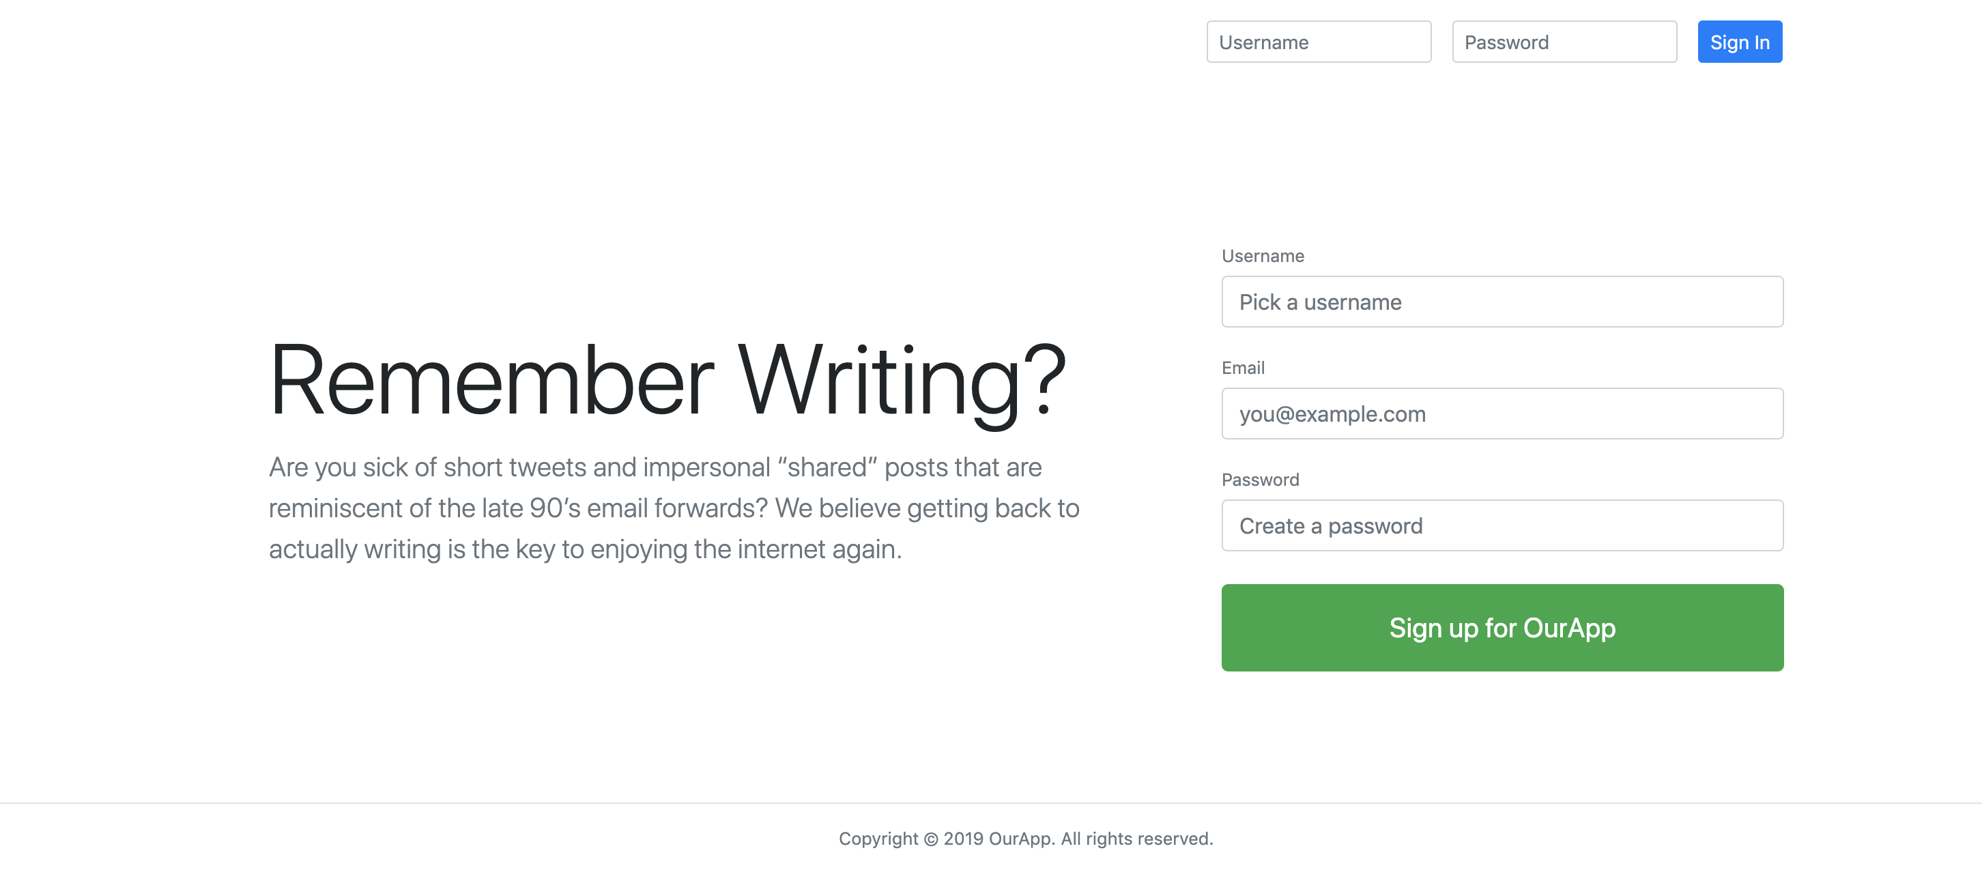
* Create a new folder that will contain the css and js files. Make the folder accessible, app.use(express.static(‘public’)), setup the main.css inside public. Link the main.css to home-guest “/main.css”

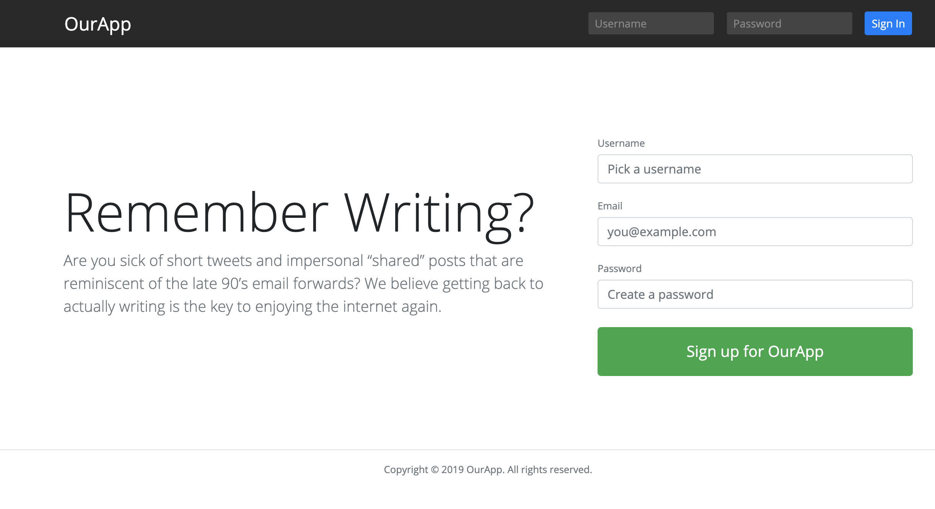

* Setup the auto-restart. npm install nodemon. Setup the nodemon at package.json, under “scripts”, set “watch”: “nodemon app”, run auto restart by npm run watch.
* Notes:
* Express is the framework
* Node server is the web browser server
* ejs is the templating engine. HTMLs are .ejs
* This is the app.js code after 41.

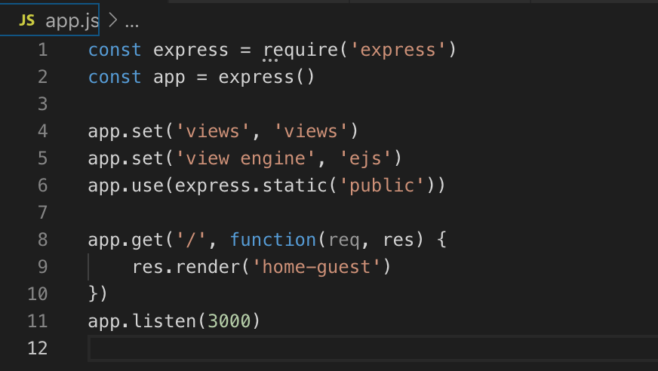

42. Important Note about Package Versions to save frustrations

“watch”: “nodemon app”,

43. What is a router?

* Router has the responsibility of listing out URLs or route that wants to listen for and say what needs to happen in that route. Idea is to stay organize by organizing different files. Each file will then work with define responsibility and be route.
* Create a file in the root, router.js.
* Setup the router, create the mini app.js version in router.js
* Connect the router.js to app.js. in router.js; module.export = router in app.js; const router = require(‘./router’)
* Remove the are from app.get as it was defined in router.js. replace it with app.use(‘/’, router). The app should run as normal.

Notes:

* + require is use for packages not created and can pull in js files that were created. require function in node executes all the contents of the file and returns what that file exports and store in the variable.
  + module.exports = node.js will execute the “=” of module.export when its been called in. it can export numbers, strings, functions and objects.

App.js and router.js at the end of 43

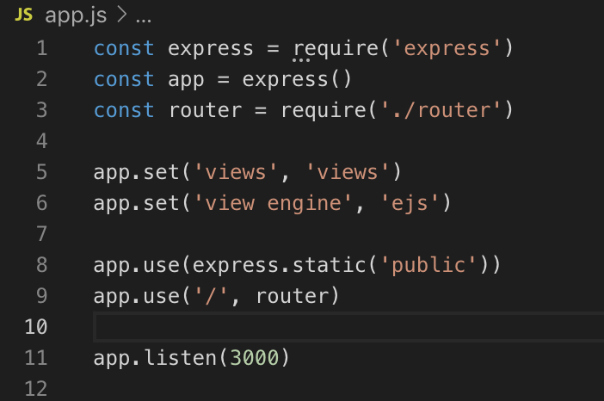 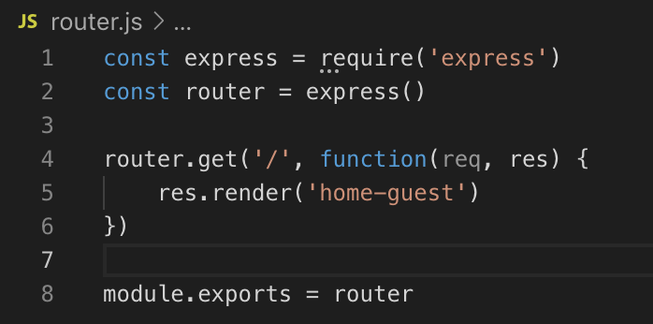

44. What is controller?

* Controller is needed to simplify more the router.js, it separates the functions and logics. It will create different function under each controller files and router can easily executes those functions. Controller will organize by feature better and let the router just do the routing.
* Create a new subfolder “controllers”. Create the following files:
  + userController.js – goal is to export multiple functions that can be access from other js files. Configure as below:
    - Connect it to router.js const userController = require(‘’./controllers/userController’)
    - Modify the router.get to router.get(‘/’, userController.home) <<< this is for home page
    - This is for register page. Modify the home-guest.ejs’ <form> from “#” to “/register”



* + - In router.js, coinfigure the register = router.post(‘/register’, userController.register)
    - Assign the function of the exports.register pointing the render to
  + postControllers.js
  + followControllers.js
* Note:

MVC = model view controller; keep code organized.

* Files at the end of 44

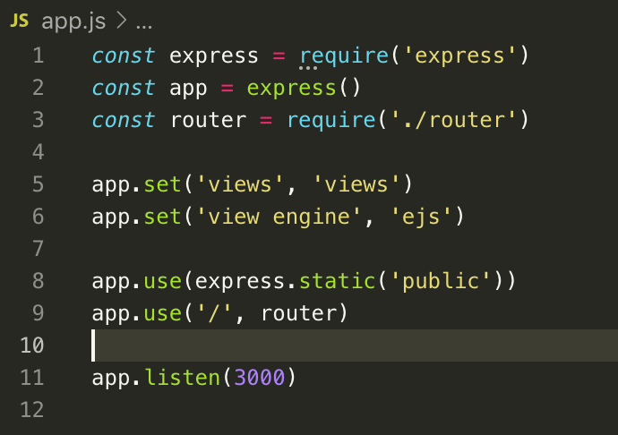

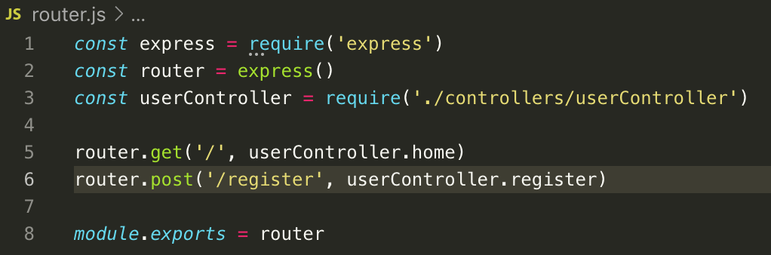

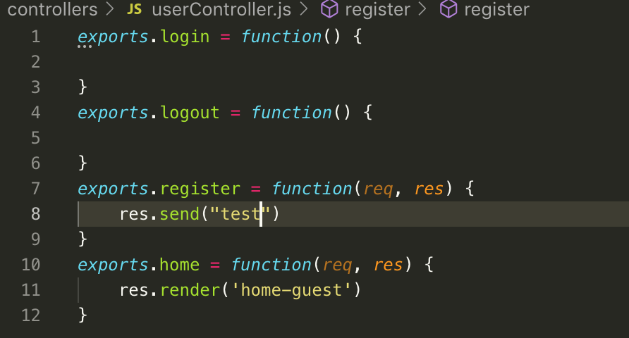

45. Security note – temporarily do not use significant password.

46. What is a model? >>> define the structure of data. Nouns and verbs in English and properties and methods in objects.

* Configure the express app. Add app.use(express.urlencoded({extended: false})) --- this tells express to add the user submitted data on to request object and access from req.body. Add, app.use(express.json()). The application now accepts two most common ways of submitting data on the web. Traditional html form submit and sending a bit of json data.
* Create models subfolder, create User.js. create let User = function {} <<< this will serve as the constructor that will hold all the validations. Export this variable (module.exports = User. Import it at userController.js, const User = require(‘../models/User)
* At userController.js, Create let user = new User(req.body) under exports.register. req.body = data acquired from the form. “new” creates new object using User as the blueprint. User is defined at Users.js
* At User.js, create the variable constructor function(data), the data here is the recipient of the data coming from the req.body, the form submission.
* “this.data”, is the set property of the function. ‘data’ here is any name, this is supposed to be pointing at the let User as it is the one calling the function. However, because of “new” in the userController.js, it now points to the let user variable, and the new object is now assigned to let user variable.
* User.prototype.register = function() {} = this syntax will make javascript not to create a copy of the function for new object created. All object created using the let User constructor has the access to this function. ‘register’ is the method. This is very useful for thousands of new object created.
* Note:

Constructor function – reusable blueprint of an object.

“this” keyword is use to point to what calls the function. This made the blueprint flexible.

After 46

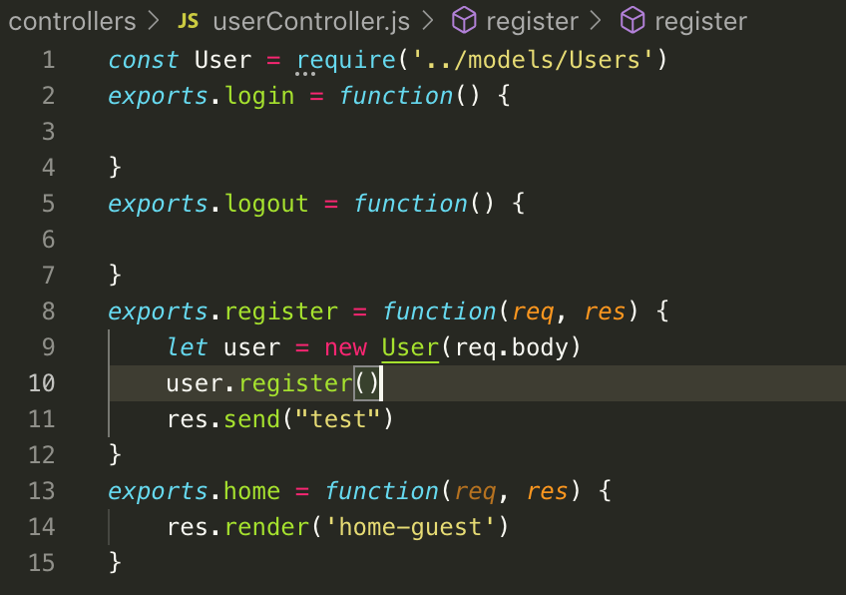

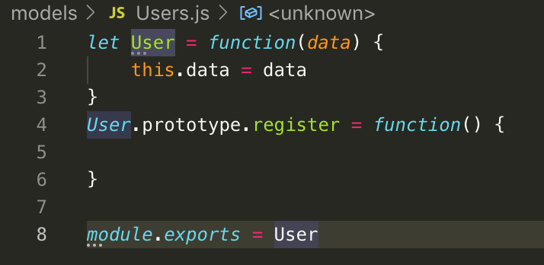

47. Adding validation to our model

* Configure .register at userFunction.js to make it work. .register was derived. The objective is to
* Create a validation requiring the 3 input filled not to be blank and correct information is to be input upon pressing the “Sign up for our App” button.
* 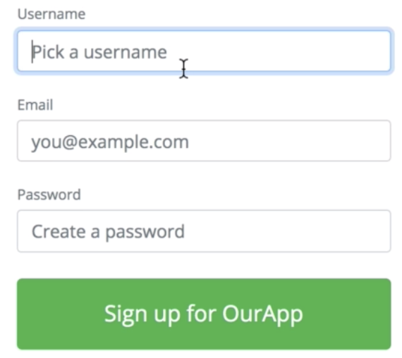
* At User.js, create the following criteria.
* Step 1. Validate user data
* Step 2. Only if there’s no validation error then save the user data into a database.
* Create User.prototype.register = function(){

this.validate() <<< see note 1

}

* Create an if statement to User.prototype.validate = function() {

If (this.data.username == “){

}

}

* Create this.errors = [] in User.js>>> this will push errors in the above if statement if statement is not met, this is same as the email and password. Complete the if statement and push this.error = [].
* Create an if statement in exports.register. this will validate if there’s no value input in the 3 fields. If (user.errors.length) = .errors is an array thus giving an access to the method .length. the statement will be true if the given .length value > 0.
* Additional validation:
* For security reason in password,

let the password should be 12 characters, if (this.data.password.length > 0 $$ this.data.password.lemgth <8) {this.errors.push(“Password must be at least 8 characters )}

let password > 100 characters.

* For username set as well. Should use valid characters if(this.data.username != “” && validator.isAlphanumeric(this.data.username)) {“Username can only contain letters and numbers}
* For email, use npm package email validator package. Npm install validator. Import the package downloaded. Const validator = require (‘validator’).

If (validator.isEmail(this.data.email)){this.error.push(“You must provide a valid email)}. Use “!” as reverse application.

Note:

1. this.validate points to whoever calls the current function. In this case the current function is the .register and is being called at userController.js via user.register(). This made this ‘user’ be ‘this’, then it has an access to the prototype blueprint .validate. Thus this.validate also means user.validate.
2. other validation for username for incvalid characters, @ for email and number of characters in password are pending.

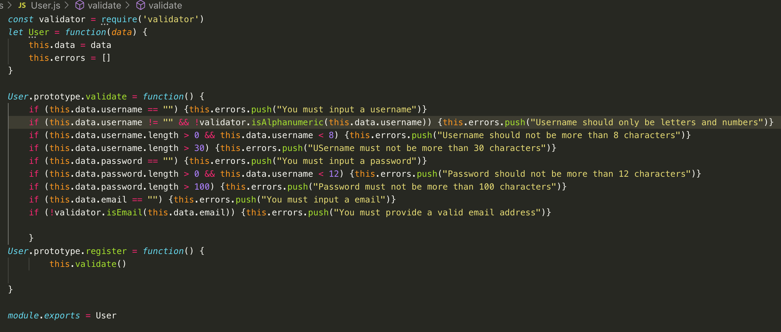

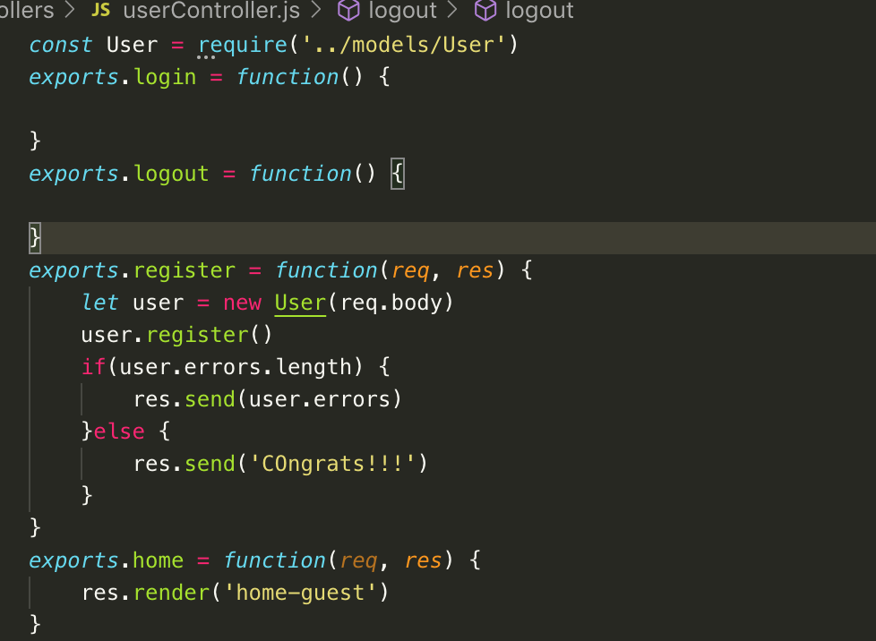

48. Quick Miscellaneous Clean Up

* Input field should accept only strings and numbers, no object or arrays.
* @ userController add, @ User.prototype.register = function(){

this.cleanup() <<< clean up can be other name

this.validate()

}

* @userController.js, create a blueprint constructor for cleanup; User.prototype.cleanUp = function(){
* If(tyoeof(this.data.username)) != “string) {this.data.username = “”}

}

* To get rid of bogus properties; @ user.js. this is to purify data property

this.data = {

username: this.data.username.trim().toLowerCase()

email: this.data.usernam.trim().toLowerCase()

password: this.data.password

}

* .trim = For further cleanup

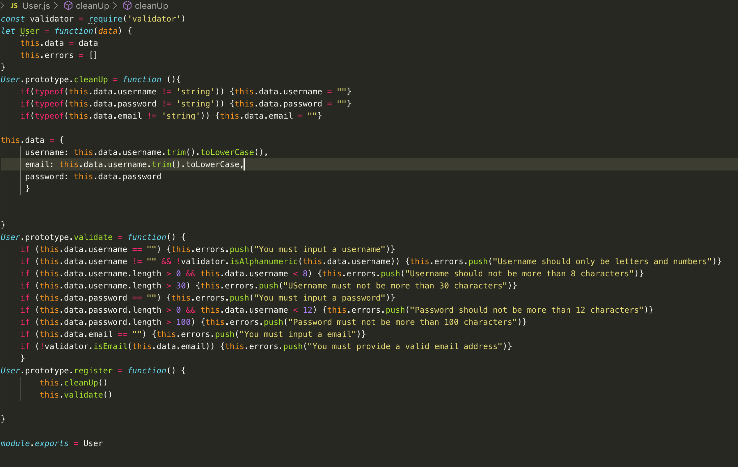 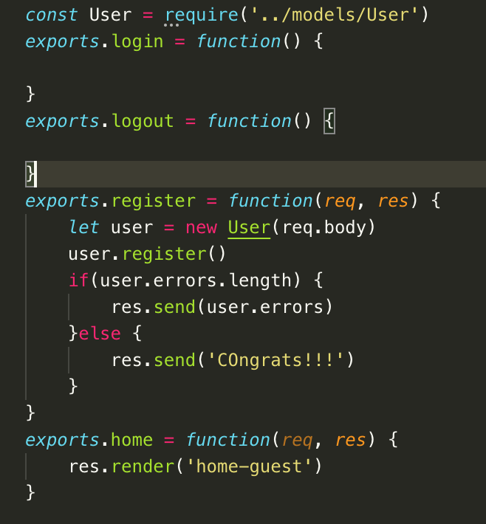

49. Connecting to Database in a Re-usable Fashion

* Create a mongoDB
* Connect the app to new DB once in a separate file who’s entir job is to connect to DB and xuse in each model.
* Create ‘db.js’ file and create a connection to mongoDB. Npm install mongodb.
* @ db.js, const mongodb = require(‘mongodb’)
* Mongodb(a, b, c)

a = connectionString, link from mongoDB

b = {useNewURLParser: true, useUnifiedTopology: true}

c = function(error, client){

module.exports = client.db()

const app = require(‘./app’)

app.listen(3000)

}

* **Above will make the app to display after a successful connection to db. The setup is perfect now for MVC setup.**
* @ app.js; remove app.listen(3000) then replace with module.exports = app. This just transfers the connection to db to db.js from app.js file.
* Then revise “watch”: “nodemon app” to “nodemon db”
* Connect Users.js; const usersCollection = require(‘../db’).collection(“users”); “users” is from mongoDB collection. db, because it was module.exports = object client.db().
* This can now do CRUD
* In Users.prototype.register = function…. + if statement

If(!this.errors.length) {usersCollection.insertOne(this.dataxq)}

50. Best Practive Time out: Environment Variables

51. Quick Note

52. Letting users Log in

53. What is a promise Part 1

54. What is a promise Part 2

55. Running Multiple Promises Efficiently when order doesn’t matter

56. Hashing user passwords

57. How can we identify or trust a request?

58. For those who are in a hurry

59. Understanding Sessions

60. Letting users logout

61. Adding flash messages

62. User registration improvements (Part 1)

63. User Registration Improvements Part 2

64. Adding user profile photos